COS 226 Algorithms and Data Structures Fall 2008

Midterm Solutions
- 8 sorting algorithms. 0652493871
- Sorting equal keys.
- Analysis of algorithms.

Insertion | A0 | A1 | A2 | A3 | A4 | A5 | A6
Selection | A0 | A1 | A2 | A3 | A4 | A5 | A6
Shellsort | A0 | A1 | A2 | A3 | A4 | A5 | A6
Mergesort | A0 | A1 | A2 | A3 | A4 | A5 | A6
Quicksort | A4 | A3 | A5 | A6 | A0 | A2 | A1
Heapsort | A1 | A2 | A3 | A4 | A5 | A6 | A0

(a) I and II only
Big-Oh notation and tilde notation both suppress lower order terms.
(b) I only
Amortized analysis provides a worst-case guarantee on any sequence of operations starting from an empty data structure.
1
4. Binary heaps.
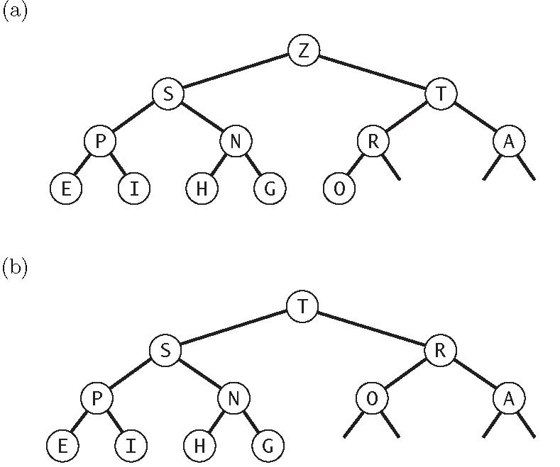
(c) True.
5. Ordered-array implementation of a set.
add(key) | add the key to the set | N
contains(key) | is the key in the set? | log N
ceiling(key) | smallest key in set ≥ given key | log N
rank(key) | number of keys in set < given key | log N
select(i) | ith largest key in the set | 1
min() | minimum key in the set | 1
delete(key) | delete the given key from the set | N
iterator() | iterate over all N keys in the set in order | N

2
6. Red-black trees.
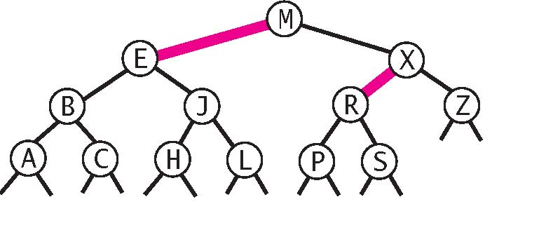
7. Line intersection.
(a) There are two cases:
- If the two lines have the same slope (a0 = a1), then return no intersection.
- Otherwise, the point (x, y) of intersection is given by:

b1 − b0
x = − ,y = a0x + b0
a1 − a0
(b) To determine whether the ith line is involved in an intersection with 3 (or more) lines:
- Create a symbol table with key = point, value = list (say, a queue) of lines.
- For each line j

= i in order:
- Compute the intersection point p between line i and line j.
- If they don’t intersect, continue.
- If the key p is not already in the symbol table, add an entry to the symbol table with key = p and value = empty list.
- Add line j to the end of the list associated with p.

• For each key in the symbol table, if it’s list contains 2 (or more) lines, they correspond to 3 (or more) lines intersecting at a single point (line i, plus the lines in the list).
Implement the symbol table using a separate-chaining (or linear-probing) hash table so that each insert/search takes O(1) time. Thus, the overall subroutine takes O(N) time.
To determine whether any 3 (or more lines) intersect at a point, run the previous subroutine N times, once for each line i. The total running time is O(N2).
(c) Only print out a set of lines in the last step of the subroutine if the index of the ﬁrst line in the list is greater than i. This guarantees we only ﬁnd a set of lines once, when using the line with the smallest index as the base line.
3

